Home and Community Support Sector Complaints Categorisation Guidance

All Te Whatu Ora Districts

Background
In 2011 the Office of the Auditor Generals’ report on home-based support noted that there are very few recorded complaints about services. A recommendation was made for district health boards to work collaboratively with others to develop a complaints system for people to confidently raise any concerns about their services.
In response to this Ministry of Health worked with Home and Community Support Service (HCSS) representatives to develop resources for consumers that encourage older people to raise concerns/complaints. This complaints categorisation and reporting process was piloted in 2013/14 and included in all HCSS agreements in 2015. Over time attrition has resulted in inconsistent reporting of complaints using the reporting process and template. Provider and funders have updated the process and agreed that it be used consistently by all districts.

What is a Complaint?
A complaint can be defined as any expression of dissatisfaction on a client’s behalf to a responsible party.
Older adults or their family/whānau may not always use the word complaint when they contact their HCSS Provider – it may be couched as a negative comment, concern, or opportunity for improvement, but it is important to recognise these as complaints under the complaints process.

Examples of complaints that your organisation might receive are:

- A staff member being careless; compromising safety or the safety of anyone they are working around (for example, by not using equipment properly); or not completing tasks properly
- A staff member manages their time poorly (for example, frequently arriving late at a client’s home) or even not turning up at all, without warning or good reason
- A staff member being abusive (physical, verbal or emotional)
- A staff member being dishonest
- A Nurse performing an incorrect procedure

A client may have a niggle that can become a major concern so treat niggles under the complaints process – it doesn’t mean a full investigation will occur but will mean the niggle will have visibility, can be easily resolved, and will contribute to wider improvement across the HCSS organisation.

Building the Right Culture
HCSS providers need to foster a culture of openness and transparency and having a philosophy of ‘putting things right to improve services will encourage complaints and concerns to be raised.

Staff need to know that an increase in the number of complaints is not a symptom of a deteriorating service therefore they need to see the outcome from complaints and how this information is used positively by the organisation.
For front line staff a mechanism needs to be in place for reporting complaints that may have been resolved ‘on the spot’ to ensure they have visibility to the HCSS provider. It is often these easily resolved complaints that provide useful insights to improving service quality.

The Ministry of Health website page “What you can expect from home support services” https://www.health.govt.nz/your-health/services-and-support/health-care-services/services-older-people/what-you-can-expect-home-support-services provides information to advise service users of their rights including the right raise a concern or make a complaint. Home and community support providers will keep a record of all complaints from service users and whanau in complaint management and reporting systems and keep a log of all complaints for reporting purposes.

Process for Categorising Complaints
- There are three steps required when categorising your organisations complaints.

Step 1: Categorise
Consider the concern/complaint your organisation has received and categorise using Table 1. If the complaint fits more than one category, then select the lead category.

Table 1: Categorisation table

Complaint Categorisation for Reporting to Funder | Health & Disability Commissioner (HDC) Rights
Attitude | RIGHT 1: Right to be Treated with Respect  RIGHT 3: Right to Dignity and Independence
Discrimination & Harm | RIGHT 2: Right to Freedom from Discrimination, Coercion, Harassment, and Exploitation
Service Delivery | RIGHT 4: Right to Services of an Appropriate Standard
Communication | RIGHT 5: Right to Effective Communication  RIGHT 6: Right to be Fully Informed  RIGHT 7: Right to Make an Informed Choice and Give Informed Consent  RIGHT 9: Rights in Respect of Teaching or Research
Advocacy | RIGHT 8: Right to Support  RIGHT 10: Right to Complain

For Example,

THE PHONE CALL...I am disappointed in the service that my mother received this week from her support worker.
My mother had family visiting when the support worker arrived over an hour late. The support worker failed to introduce herself to the visitors, and when my mother was receiving her shower the bathroom door was left open, so everyone could hear what was being said about toileting, cleaning dentures….
THE APPROACH TO CATEGORISING …When categorising the complaint consider which HDC RIGHT has been most impacted. You might consider Attitude (failing to close the door thereby not treating the person with respect and dignity) or Communication (failing to notify the client she would be late). Select the LEAD category.

Step 2: Evaluate
Evaluate the impact of the concern/complaint utilising the likelihood and consequence matrix in Table 2. For all complaints report the actual outcome and for all concerns rate the potential outcome. Management of the concern/complaint depends on the level of risk to a client, staff or organisation.

Table 2: Likelihood & consequence matrix for Home & Community Sector complaints
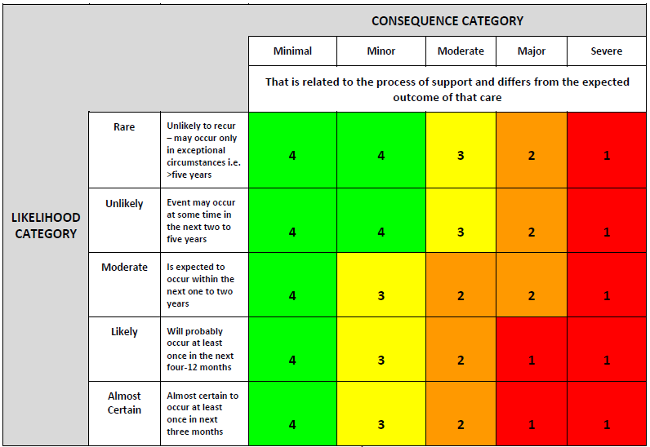

Step 3: Severity Assessment & Reporting Process
Determine the Severity Assessment Code (SAC). The SAC Matrix (Table 3) assists organisations to prioritise and classify incidents based on severity. The scoring system provides clear direction about complaints reporting requirements.

Table 3: SAC coding and reporting process
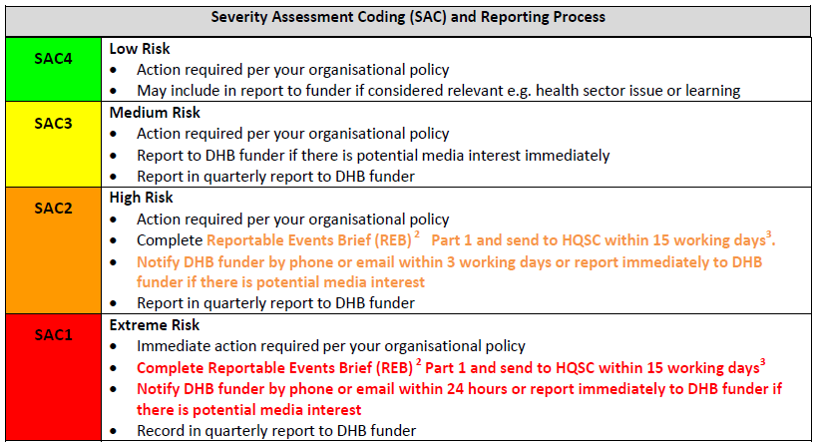

DHBs acknowledge that HCSS providers will respond to and manage complaints in alignment with the Home and community support sector Standard (NZS8158:2012) and their own organisations policies. However, where there is a potential for media interest, providers are requested to inform their DHB funder. This will allow the DHB to provide support where indicated and respond in a timely manner to media questions.

For more information on the Health Quality and Safety Commissions ‘National Reportable Events Policy’ please click here: http://www.hqsc.govt.nz/our-programmes/reportable-events/national-reportable-events-policy/. This hyperlink also provides questions and answers on the policy, the Reportable Events Brief (REB) and related resources.

Appendix 1: Examples of Consequences
Table 4 provides examples of concerns/complaints an organisation may receive. The examples listed here are not exhaustive and should only be used as a guide to assist in determining the consequence of the concern/complaint.

Remember that any expression of dissatisfaction should be recorded, even if it is resolved on the spot. It doesn’t need to be a formal complaint to be captured in this process

Table 4: Examples of Consequences

Minimal | Minor | Moderate | Major | Severe
That is related to the process of support and differs from the expected outcome of that care.
Poor attitude of staff member to client | Service delivery action or inaction that results in first aid treatment | Client has sought advocacy support from the Nationwide HDC4 Advocacy Service | Any incident as a result of action or inaction requiring the need for the client to visit a health professional e.g. fall resulting in fracture | Staff member actions such as theft that results in a criminal conviction
Staff member unintentionally breaks client property of low monetary value | Staff member actions such as alleged theft less than $100 client chooses not to take to Police for investigation | Staff member actions such as alleged theft of an item value greater than $100 where the client chooses not to take to Police for investigation | Action or inaction that results in referral to external agency or police intervention | Action of staff member that results in a privacy or confidentiality breach that attracts nationwide media attention
Allegation of theft less than $50 which is unsubstantiated | Action of staff member that results in an alleged privacy or confidentiality breach to an identified group of people | Action of staff member that results in an alleged privacy or confidentiality breach that attracts local media attention | Complaint made to the HDC regarding a client’s support | Allegation of rape
Action of staff member that results in an alleged privacy or confidentiality breach (verbal) to one person only | Interruptions in service delivery resulting in client dissatisfaction | Threatening sexual inappropriateness such as language used or touching | Staff members actions such as proven theft resulting in instant dismissal of staff member | Crossing of professional boundaries resulting in dismissal of the staff member
Non-threatening sexual inappropriateness such as dress standard | Staff member unintentionally damages client property of high monetary value | History of non-witnessed abrasions/bruising | Action of staff member that results in a privacy or confidentiality breach that attracts regional media attention
Complaint related to client misunderstanding of support available through needs assessment | Cultural breach by staff member |  | Sexual inappropriateness such as touching resulting in referral to police
Miscommunication between staff or client and staff that effects client | Crossing of professional boundaries resulting in client/family/whānau dissatisfaction |  | Interruption in service delivery resulting in a threat to client’s safety (at home)

1 Adopted from the Health Quality and Safety Commission SAC Framework

