Ministry of Health In-Between Travel Update, January 2016
This update provides important information to you about Ministry of Health & DHB arrangements for the March 2016 implementation of the settlement.

We are now entering the implementation phase of the new In-Between Travel system, thanks to the work of the many interested parties.

This guidance is now being provided to assist you in preparing for the March 1, 2016 move from the interim system to the new IBT system.

The purpose of this document is to lay out to providers / employers and funders, a wide range of the areas or issues impacted by the new system.

It includes technical guidance, and a number of simple scenarios on how to apply IBT.

As with any new model, we expect there to be a need to refine our guidance as we receive feedback from various parties, and real-world experience of how the system is working. It is important that we receive such feedback from you, so we can constructively address any issues.

Please take the time to consider the information below. We value your views and if you have general questions or feedback about the information here, please email us at ibt@moh.govt.nz
Background on In-Between Travel

In 2014, the Ministry of Health entered negotiations to find a solution that would lead to home support workers getting paid for the time they spend travelling between clients. This is referred to as In-Between Travel (IBT).

In March 2014, negotiations with unions, employers and funding agencies opened, and were successfully concluded in September of that year.

The agreement was ratified in June 2015; due to the short time available to have systems in place, it was agreed there would be an interim settlement until the full settlement is implemented in 1 March 2016. Parties then agreed a variation to the agreement in August 2015.

Following the in-between travel negotiations in 2014 and the subsequent settlement, legislation has been introduced and has just completed the Select Committee stage. It is expected the final processes will occur in February 2016 and the legislation will be enacted prior to the full settlement implementation on 1 March 2016. The legislation can be found on the Parliamentary legislation website and is called the Home and Community Support (Payment for Travel Between Clients) Settlement Bill.

http://www.parliament.nz/en-nz/pb/legislation/bills/00DBHOH_BILL65996_1/home-and-community-support-payment-for-travel-between
The Bill describes the Home and Community Support (HCS) services as those funded by the Ministry of Health or a DHB that are performed in a client's home for the purpose of assisting the client to continue to live in their own home; and services funded by ACC that are performed in a client's home for the purposes of supporting a client's rehabilitation from an injury covered by the ACC Act and to achieve and sustain the client’s maximum level of participation in everyday life.

The Bill also describes the payment for travel between clients, the amendments to other legislation that has been necessitated by the introduction of this new Bill and then provides Schedules which list former HCS employers, current HCS employers and the final Schedule which describes the mileage rate, qualifying distance, qualifying travel time and maximum travel distance.

The legislation is intended as a "one stop shop" where employers can check their obligations and employees can check their entitlements. It also extinguishes retrospective and future claims, amends the Minimum Wage Act and limits the liability of employers to specific travel payments.

Here is a link to the report-back version of the Bill, posted on the Parliamentary website;
http://www.parliament.nz/resource/en-nz/51DBSCH_SCR68161_1/0b26241ec52d6d4f40b3ad98495272a392993a14

From March 1, 2016, the full IBT settlement is to take effect and this document is to provide important information to providers and interested parties around the implementation of the new system. There will be separate guidance provided at a later date that can be provided to employees.
Background on changes to Fair Travel
In 2005/6 the Ministry of Health and District Health Boards increased funding to Home and Community Support providers to reimburse support workers for travel costs (Fair Travel). This funding was rolled into contracts for home and community support services. However, the amount of funding does not recognise the full “mileage” cost to workers or the cost of time taken by them to travel between clients.
The In-between settlement addresses issues associated with both workers’ travelling time and the reimbursement of travel cost. Because the in-between funding recognises the full mileage costs fair travel funding will be removed from all contract rates from 29 February 2016 and replaced with the model described in this paper. In addition any current funder specific exceptional travel arrangements will cease.

Contents of this document
Contained below are:
- A summary of the Ministry’s agreed funding model
- A summary of how the payments will be administered from 29 February, 2016
- The one band model –
  - What employers will receive and what employees will receive from 29 February 2016
  - Changes from the interim payment period
  - Treatment of Travel Time Payments
  - Final agreed travel distance cost
- Exceptional travel
- Fair travel funding.
- Claiming
  - Three additional columns are required
  - Will I need to build an authorisation process into my system?
  - IBT scenarios and calculations
  - Audit
- Contract variations
- Treatment of ‘No worse off’
- Examples (in appendices) of updated claim form, provider report and Buyer Created tax Invoice

1. What is the Ministry’s agreed funding model?
Negotiating parties have agreed upon a one band model for all travel up to 15 km, other than first visit (defined as travel by the employee to the first client visit of the day) and exceptional travel. Negotiating parties have also agreed an exceptional travel policy. For the one band, a standard payment will be made for all travel up to 15 km (other than first visit). A one band model has been agreed as analysis found the majority of visits were less than 5 kilometres and, although attempts have been made to develop a model that reflects local issues, this presented too many operational and data challenges.
Travel time and cost for the first visit will not be paid except where a visit requires travel of over 15 km (one way).
The model will be reviewed by 31 August 2016 by employers, employee representatives and funders. The parties will consider whether the model can be adapted to address significant local issues.
2. How will the payments be administered from 29 February 2016?
Due to the short timeframes to have systems in place for July 2015 an interim settlement was agreed where the Ministry has been managing the funding centrally. From 29 February 2016 In-Between Travel (IBT) funding for DHB funded home and community services will be devolved to DHBs.
3. One band funding Model effective from 29 February 2016
a. What employers invoice and what employees receive.
TABLE 1: One band
 | One band: All travel under 15 km (first visit not paid) | Employer Funding | Employee Funding
Travel time | 8.5 minutes | $2.85 (funded) | $2.09 (employees)
Travel distance | 3.7 km | $1.96 (funded) | $1.85 (employees)
Total |  | $4.81 | $3.94
Notes:

- Travel time and distance will not be paid for the first visit, unless that first visit is over 15 km, in which case time and distance will be paid for (and invoiced). See IBT Scenarios and Calculations, scenario 2b.
- Two single standard payments for travel time and travel distance ($2.09 and $1.85) are paid for all travel under 15 km except for the first visit (which is not paid). Some visits under 15 km will take more than 8.5 minutes and 3.7 km, some less, but for travel under 15 km, other than the first visit, all employees will receive the two amounts above
- The employer funding for travel time represents the hourly agreed rate of $20.10/8.5 min. The employee funding for travel time represents the minimum wage rate of $14.75/8.5 min. Travel time is a taxable payment.

- The Travel distance payments represent, for employees 3.7 km x 50c per km, and for employers 3.7km x 53c per km. This is a reimbursement and therefore non-taxable.

- The interim settlement rate did not separate out exceptional travel. From 29 February, exceptional travel will be paid. This reduces the band payment from that paid under the interim arrangement.

b. Changes from the interim payment period
The Interim band payment will be replaced with the new permanent travel band rate. The interim rates for time only of $3.10 (funded) and $2.28 (employees) for time will be replaced with the figures in Table 1 above. The reason for the difference in figures is that the interim settlement rate did not separate out exceptional travel. From 29 February, exceptional travel will be paid. This reduces the amount allocated to the band payment.
As reflected in Table 1 providers will continue to be paid the relevant proportion of $20.10 per hour for qualifying travel time and are expected to pay employees the proportion of at least the minimum wage.

c. Treatment of Travel Time Payments

Travel time payments will be treated as any other income to employees i.e. all relevant tax and employment obligations should be applied e.g. annual leave. The travel time rates will be reviewed if there are changes to the minimum wage

d. Final agreed travel distance cost.
The settlement parties agreed on a rate of 50c per kilometre for Qualifying Travel Cost imbursement. Providers will receive a 6% margin on travel mileage. Table 1 shows how this will be calculated.
The Ministry and negotiating parties will monitor the costs of in-between travel and explore moving to $0.60 per kilometre if it is affordable.

4. Exceptional travel
Exceptional travel will be paid by the relevant funder after the banded range has been exceeded.
Exceptional travel will be paid using the following policy:
Exceptional travel is paid on an actuals basis and is only payable when travel exceeds 15 km and includes the first and last visits of the day, or for subsequent visits, the location of the last client. Note that the DHB and Ministry do not normally fund the first and last visits as these visits are seen as normal travel related to attending work.
From 29th February travel will need to exceed 15kms one way to a client (from either the employees normal place of residence for the first visit, or for subsequent visits, the location of the last client) for exceptional travel to be payable.
Exceptional travel will be paid where no other home and community support employee is available who can meet the specific needs of the client. This will be determined by the employer. Employers must actively manage exceptional travel and take reasonable steps to recruit workers that meet the client’s needs in the most efficient and effective way.

The client’s specific support needs can arise from:
- their disabilities
- their medical conditions or injury
- their behaviour
- their age
- other major factors e.g. family circumstance, accommodation, employment, social involvement
- cultural, language, gender or other relevant social factors

TABLE 2: Exceptional Travel Payment
 | Employer Funding | Employee Funding
Travel time | $20.10 per hour (proportioned) | $14.75 per hour (proportioned) (min)
Travel distance | $0.53 per km | $0.50 per km

Notes:
- Where travel exceeds 15kms and the travel meets the exceptional travel policy criteria the total billable is the number of kms travelled to the client and the number of minutes to the client.
- Calculations for travel time should be rounded to the nearest minute (13min and 15 seconds should be rounded to 13mins, 13 mins and 33secs to 14 mins).
- Calculations for travel distance should be rounded to the nearest kilometre (22.2 kms should be rounded to 22km and 22.5km should be rounded to 23kms).
- The band is currently set for travel, based on a one way trip, of between (0-15km).
- Travel must occur for it to be payable.

5. Fair travel funding
The settlement parties have agreed in principle to use the following fair travel amounts (Table 3). These figures are based on the existing fair travel policies.
Table 3. Fair travel amounts
DHB | HM | PC
Auckland DHB | $2.27 | $2.31
Bay of Plenty DHB | $1.33 | $1.46
Canterbury DHB | $0.86 | $0.86
Capital and Coast DHB | $1.45 | $1.75
Counties Manukau DHB | $1.16 | $1.27
Hawkes Bay DHB | $1.78 | $1.98
Hutt Valley DHB | $1.45 | $1.75
Lakes DHB | $1.65 | $1.78
MidCentral DHB | $1.24 | $1.24
Nelson Marlborough DHB | $1.20 | $1.20
Northland DHB | $0.88 | $0.88
South Canterbury Urban DHB | $0.96 | $0.96
Southern DHB | $1.18 | $1.36
Tairawhiti DHB | $1.91 | $2.07
Taranaki DHB | $1.79 | $1.95
Waikato DHB | $2.84 | $3.23
Wairarapa DHB | $1.76 | $2.06
Waitemata DHB | $1.16 | $1.27
West Coast DHB | $1.19 | $1.19
Whanganui DHB | $1.06 | $1.15
Ministry of Health Direct to Providers | $1.20 | $1.20

HM – Household Management; PC – Personal Care.
For contracts that are funded on an hourly basis, the variations will simply reduce the existing contract prices by the amounts shown in Table 3.
For bulk funded contracts, you will need to, if you do not already, agree the annual volumes of hours with your DHB(s). The annual fair travel funding to be removed from your contracts is calculated by multiplying the annual volumes by the relevant figure in Table 3.

6. Claiming
a. Three additional columns are required as shown below
Field | Description | Note
AgreementNumber | Agreement Number for main Home and Community Support Services | This should be the six digit agreement number in valid number format e.g. 350000  This will be used to identify the correct funder as the funding will no longer be managed centrally  There will be a grace period from 28/2/2016 to 2/5/2016 where agreement numbers will not be mandatory. Payment can be made if the Funder and Bulk/FFS fields are submitted correctly.
ExcepTravelTime | Number of minutes travel time for visits eligible for exceptional travel | This should be a valid number format, rounded to the nearest full minutes (e.g. 13 min 15 secs should be rounded to 13 min, 13 min 33 secs should be rounded to 14 min)  The total number of minutes travelled for the in-between travel visit.  Please note for visits not eligible for exceptional travel this must be left blank.
ExceptTravelDistance | Number of kilometres for visits eligible for exceptional travel | This should be a valid number format, rounded to the nearest full kilometres (22.2 kms should be rounded to 22km and 22.5km should be rounded to 23kms).  The total number of kilometre travelled for the in-between travel visit.  Please note for visits not eligible for exceptional travel this must be left blank.

b. Will I need to build in any authorisation processes into my system?
There will be no pre-authorisation process implemented 29 February 2016. You will however be expected to have an audit trail available for how the travel meets the exceptional travel policy and how the kilometres and time for the visit have been calculated. We are aware there are a variety of different processes and systems being used by providers e.g. geo tagging technology and are therefore allowing flexibility in how the audit trail is provided.
If you would like to discuss the suitability of the system you have designed please contact the Ministry or your funder.

c. IBT Scenarios and Calculations
The Ministry has prepared some scenarios of visits so that you understand how to treat claims. The Ministry will be adding to the scenarios over time, and welcomes any scenarios from you. You can do this by emailing us at ibt@moh.govt.nz.

Scenario 1 – Standard Travel (No Exceptional Travel)
For each visit the following payments are calculated:
Visit | Distance | Payment
1 | 4 km | $0.00
2 | 10 km | $4.81
3 | 5 km | $4.81
Home | 3 km | $0.00

Relevant part of the claim:
IBT PSO | EmployeeID | VisitDate | VisitTime | Post Code | FirstVisit | PersonNHI | Funder | FFS/Bulk | RecordID | AgreementNumber | ExcepTravel-Time | Excep Travel-Distance
 | 1001 | 1/03/2016 | 7:00 | 1001 | Y | AAA0001 |  |  | 1 | 350000
 | 1001 | 1/03/2016 | 9:00 | 1001 | N | BBB0002 |  |  | 2 | 350000
 | 1001 | 1/03/2016 | 11:00 | 1001 | N | CCC0003 |  |  | 3 | 350000

The Provider will receive the following payment information in their claim response file:
IBTPSO | EmployeeID | VisitDateTime | PostCode | FirstVisit | PersonNHI | Funder | FFS/Bulk | RecordID | Agreement Number | Excep TravelTime | Excep Travel Distance | BandTime GST Exl | BandDistance GST Exl | ExcepTime GST Excl | ExcepDistance GST Excl | Pay Amount | Comments
 | 1001 | 1/03/2016 8:00 | 1001 | Y | AAA0001 |  |  | 1 | 350000
 | 1001 | 1/03/2016 9:00 | 1001 | N | BBB0002 |  |  | 2 | 350000 |  |  | 2.85 | 1.96 |  |  | 4.81
 | 1001 | 1/03/2016 10:00 | 1001 | N | CCC0003 |  |  | 3 | 350000 |  |  | 2.85 | 1.96 |  |  | 4.81

Scenario 2 – Round Trip Exceptional Travel
For this round trip of Exceptional Travel the following payment is calculated:
Calculation | Payment
TIME: 62 * (20.10/60)  DISTANCE: 68 * 0.53 | $20.77  $36.04
TOTAL | $56.81

Relevant part of the claim:
IBT PSO | EmployeeID | VisitDate | VisitTime | Post Code | FirstVisit | PersonNHI | Funder | FFS/Bulk | RecordID | AgreementNumber | ExcepTravel-Time | Excep Travel-Distance
 | 2002 | 2/03/2016 | 7:00 | 2002 | Y | DDD0004 |  |  | 1 | 350001 | 62 | 68

The Provider will receive the following payment information in their claim response file:
IBTPSO | EmployeeID | VisitDateTime | PostCode | FirstVisit | PersonNHI | Funder | FFS/Bulk | RecordID | Agreement Number | Excep TravelTime | Excep Travel Distance | BandTime GST Exl | BandDistance GST Exl | ExcepTime GST Excl | ExcepDistance GST Excl | Pay Amount | Comments
 | 2002 | 2/03/2016 9:00 | 2002 | Y | DDD0004 |  |  | 1 | 350001 | 62 | 68 |  |  | 20.77 | 36.04 | 56.81

Scenario 3 – Standard Travel and Exceptional Travel
For each visit the following payments are calculated:
Visit | Distance | Payment
1 | 4 km | $0.00
2 | 16 km | $15.18
3 | 5 km | $4.81
Home | 21 km | 19.51

Relevant part of the claim:
IBT PSO | EmployeeID | VisitDate | VisitTime | Post Code | FirstVisit | PersonNHI | Funder | FFS/Bulk | RecordID | AgreementNumber | ExcepTravel-Time | Excep Travel-Distance
 | 3003 | 3/03/2016 | 7:00 | 3003 | Y | EEE0005 |  |  | 1 | 350000
 | 3003 | 3/03/2016 | 9:00 | 3003 | N | FFF0006 |  |  | 2 | 350000 | 20 | 16
 | 3003 | 3/03/2016 | 11:00 | 3003 | N | GGG0008 |  |  | 3 | 350000
 | 3003 | 3/03/2016 | 13:30 | 3003 | N | GGG0008 |  |  | 4 | 350000 | 25 | 21
Note that the long (Exceptional) trip home can also be claimed. Since there is no client to visit, the NHI and Agreement number in the claim should be the last client visited so that the funding can be provided by the appropriate funder. The visit time should be time of the arrival home and not again the start of the visit at the last client since that would be considered a duplicate claim.
The Provider will receive the following payment information in their claim response file:
IBTPSO | EmployeeID | VisitDateTime | PostCode | FirstVisit | PersonNHI | Funder | FFS/Bulk | RecordID | Agreement Number | Excep TravelTime | Excep Travel Distance | BandTime GST Exl | BandDistance GST Exl | ExcepTime GST Excl | ExcepDistance GST Excl | Pay Amount | Comments
 | 3003 | 3/03/2016 7:00 | 3003 | Y | EEE0005 |  |  | 1 | 350000
 | 3003 | 3/03/2016 9:00 | 3003 | N | FFF0006 |  |  | 2 | 350000 | 20 | 16 |  |  | 6.70 | 8.48 | 15.18
 | 3003 | 3/03/2016 11:00 | 3003 | N | GGG0008 |  |  | 3 | 350000 |  |  | 2.85 | 1.96 |  |  | 4.81
 | 3003 | 3/03/2016 13:30 | 3003 | N | GGG0008 |  |  | 4 | 350000 | 25 | 21 |  |  | 8.38 | 19.51 | 19.51

Scenario 4 – Standard Travel and Exceptional Travel, mixed funding (Ministry of Health / DHB claiming only)
For each visit the following payments are calculated:
Visit | Distance | Payment
1 | 4 km | $0.00
2 (ACC) | 20 km | ACC
3 | 17 km | $15.71
Home | 10 km | $0.00

Relevant part of the claim:
IBT PSO | EmployeeID | VisitDate | VisitTime | Post Code | FirstVisit | PersonNHI | Funder | FFS/Bulk | RecordID | AgreementNumber | ExcepTravel-Time | Excep Travel-Distance
 | 3003 | 3/03/2016 | 7:00 | 4004 | Y | HHH0009 |  |  | 1 | 350000
 | 3003 | 3/03/2016 | 11:00 | 4004 | N | KKK0011 |  |  | 3 | 350000 | 20 | 17
Only the visits to clients H (HHH0009) and K (KKK0011) can be claimed with the MoH, the visit to client J is to be claimed with ACC.

The Provider will receive the following payment information in their claim response file:
IBTPSO | EmployeeID | VisitDateTime | PostCode | FirstVisit | PersonNHI | Funder | FFS/Bulk | RecordID | Agreement Number | Excep TravelTime | Excep Travel Distance | BandTime GST Exl | BandDistance GST Exl | ExcepTime GST Excl | ExcepDistance GST Excl | Pay Amount | Comments
 | 3003 | 3/03/2016 7:00 | 4004 | Y | HHH0009 |  |  | 1 | 350000
 | 3003 | 3/03/2016 11:00 | 4004 | N | KKK0011 |  |  | 3 | 350000 | 20 | 17 |  |  | 6.70 | 9.01 | 15.71

d. Audit
The Ministry of Health’s Audit & Compliance team will closely monitor and audit IBT claims to the Ministry and DHBs.
Funders expect that:
- providers are able to demonstrate that rostering of workers is appropriate and efficient i.e.home and community support workers are rostered to minimise IBT costs.
- providers keep adequate and accurate records to support claims for exceptional travel for a client (including documentation of exceptional time and distances incurred).
Funders appreciate that the new scheme may take a little time to settle-in so some tolerance will be allowed initially. However, failure to provide adequate and accurate documentation of claims will be disputed and could lead to action to recover payment for those claims.

7. Contract Variations
The Ministry has started sending out contract variations and will keep doing this during the first months of 2016. The variation will;
- Remove existing fair travel funding and any other travel related funding (This funding
will be used to partially offset the costs of IBT)
- Add the IBT travel components i.e. travel time, mileage, and exceptional travel.

If you deliver home and services and don’t have a contract with an agreement with a six digit agreement number in valid number format i.e. 350000 then you will need to talk to your funder. Your funder will need to work with Sector Operations to ensure a contract is developed for payment to occur.

There will be a grace period from 28/2/2016 to 2/5/2016 where agreement numbers will not be mandatory. Payment can be made if the Funder and Bulk/FFS fields are submitted correctly. In that case, a funder needs to be one of the recognised 3 letter abbreviations. Anything else will not be interpreted and that claim line will be rejected. The Bulk/FFS field can only contain “FFS” or “Bulk”. Anything else will not be interpreted and that claim line will be rejected. If an agreement number is included, the Funder and Bulk/FFS fields will be ignored.
DHB Code  to be used in IBT claims | DHB
NLD | Northland DHB
NWA | Waitemata DHB
CAK | Auckland DHB
SAK | Counties Manukau DHB
WKO | Waikato DHB
LKS | Lakes DHB
BOP | Bay of Plenty DHB
TRW | Tairawhiti DHB
TKI | Taranaki DHB
HWB | Hawkes Bay DHB
WNI | Whanganui DHB
MWU | MidCentral DHB
HUT | Hutt Valley DHB
CAP | Capital and Coast DHB
WRP | Wairarapa DHB
NLM | Nelson Marlborough DHB
WCO | West Coast DHB
CTY | Canterbury DHB
SCY | South Canterbury DHB
OTA | Southern DHB
MOH | Ministry of Health

8. Treatment of “no worse off”
a. If an employee feels they are disadvantaged they should raise this with their employer as an employment relationship problem for the purposes of the Employment Relations Act 2000. The comparison should normally be made between the employee’s usual travel-related remuneration (based on the employee’s employment agreement) in the four weeks prior to 1 July 2015 and the four weeks following full implementation of the agreement on 29 February 2016.
b. Where a provider believes they are disadvantaged they should raise this with the funder. The comparison should be between funding and required payments to employees before 1 July 2015 and funding and required payments after 29 February 2016. There will be a national mediation mechanism if the provider and funder are unable to resolve the issue.
c. In all cases the parties must work together in good faith and with urgency to remedy any alleged financial disadvantage.
d. More information is available in the variation to the settlement.
The parties to the in-between travel settlement agreement have agreed a variation to the agreement. The variation sets out the mechanism and process for dealing with any issues of disadvantage as a result of implementing the settlement agreement. The variation can be downloaded along with the settlement agreement and should now be read in conjunction with the settlement agreement.
Appendix 1 - File specification for IBT Claims after 29 Feb 2016

Main changes:
The main changes needed can be summarised as follows:
- Distance component added to the travel band
- Exceptional Travel (time and distance) added
- Change in the funding source: DHBs and MOH instead of only MOH
- Therefore; changes in the claim template and changes in the reports:
      - Separate payment in base band time and distance, add ET time and distance.
      - Add summary per funder and per contract, also separated in base band time and distance, add ET time and distance. GST is added at contract level.
- A single travel band was confirmed

Template changes:
- Add Agreement number (6 digits, not starting with a 0, ie 350001)
- Add actual Exceptional Travel Time (max 3 digits, full minutes, no decimals (will be rounded if added)).
- Add actual Exceptional Travel Distance (max 3 digits, full kilometres, initially not less than 15km for a single trip, no decimals (will be rounded if added).

Notes:
For Exceptional Travel: always claim the full door-to-door time and distance.
For a first visit, also claim the full door-to-door time and distance.
The sample files shown in appendix 2-5 are embedded below, as well as a .csv formatted claim template.

Appendix 2: Claim file specification for visits on or after 29 Feb 2016.
As before, the file upload mechanism stay the same; using “comma separated files” (.csv).
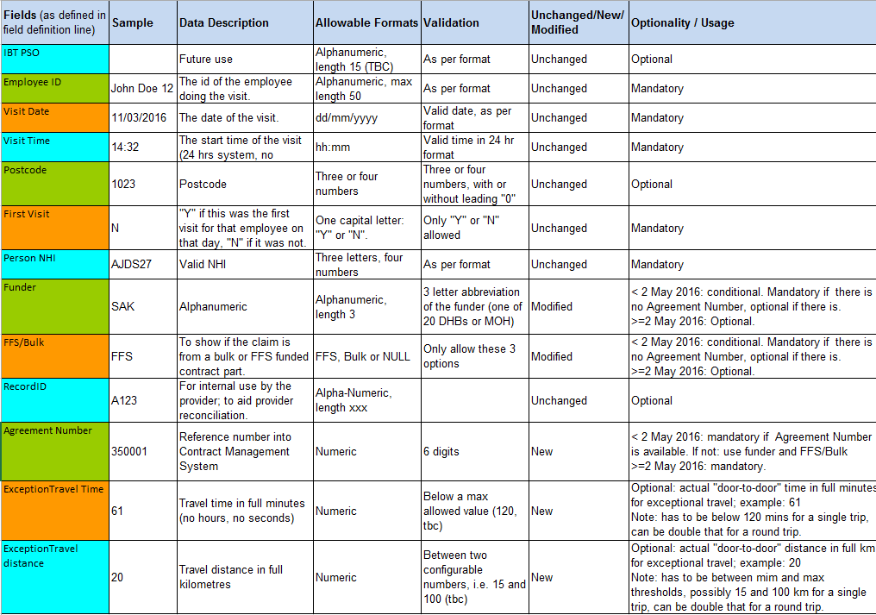

Appendix 3: Annotated claim template for visits on or after 29 Feb 2016
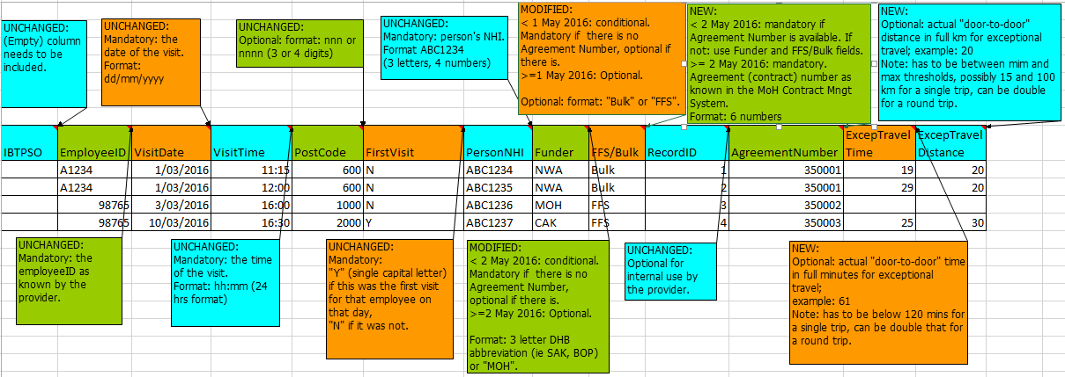
Appendix 4 Example updated claim file for visits on or after 29 Feb 2016
Shaded columns optional.
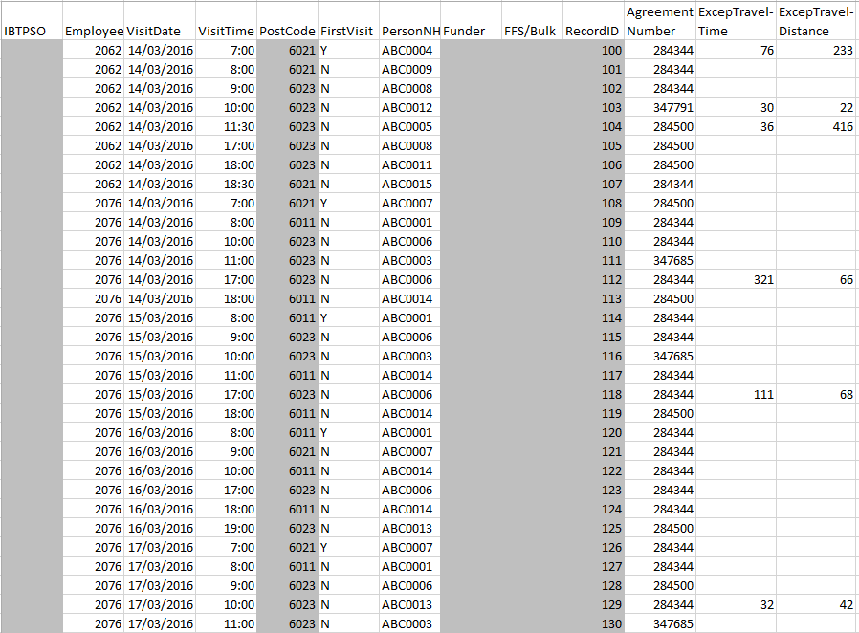

Appendix 5: Draft updated provider report for visits on or after 29 Feb 2016, subject to change
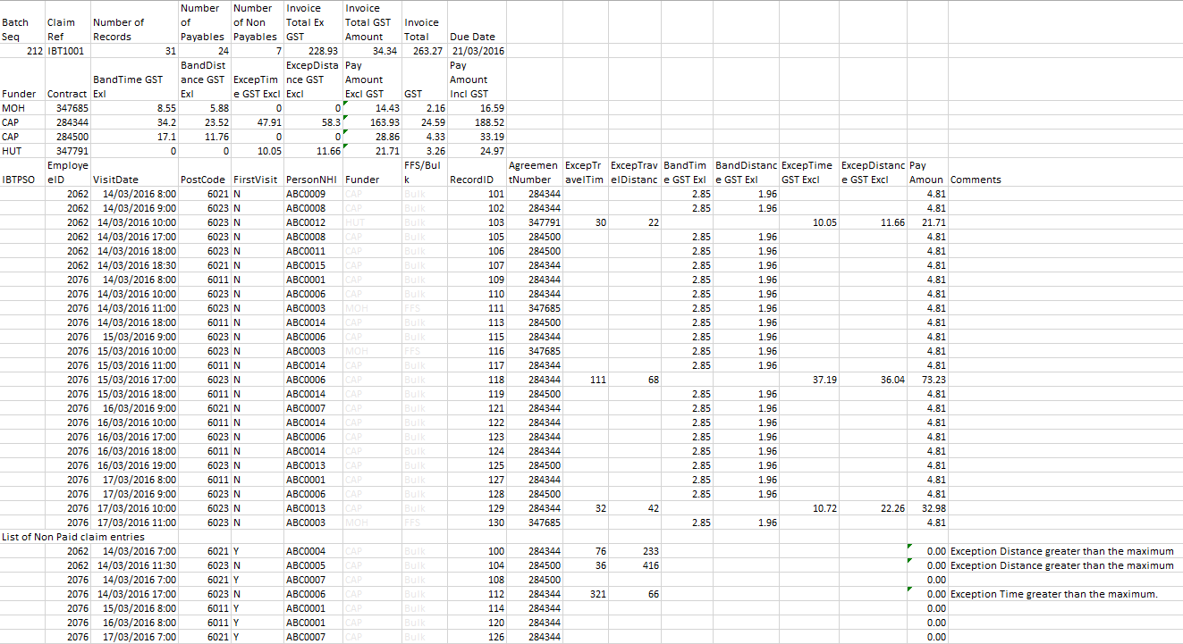

Home and Community payments systems are based on Monday to Sunday schedule. The 29th of February 2016 is the closest Monday to the 1st of March 2016, and therefore is the effective start date.
Refer to Section 6, Claiming.

